How to make cloud dough
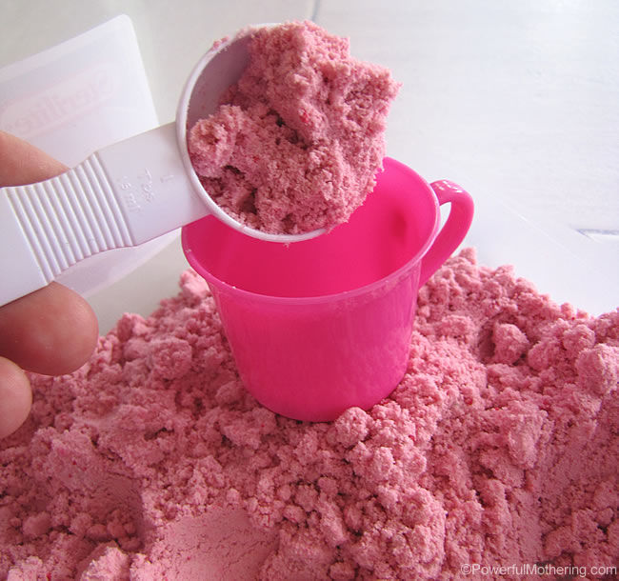
We made our cloud dough with vegetable oil to make it edible and ultimately taste safe, meaning if your child were to take a taste said child would be perfectly fine.
To make cloud dough mix in the 1:8 ratio. That is 1 cup of oil to 8 cups of flour.
Ingredients
- All purpose flour
- Vegetable oil
- Oil based food coloring or powder food coloring
- a bowl for mixing

Method
- Mix your ingredients in a bowl. You will have to get your hands into the mix to pinch the flour to distribute the oils and colouring.

