Sensory Messy Play At Home
Sensory messy play is a great way for children to practice their fine motor skills and learn how to use tools. You can also use this activity to work on lots of different learning skills, below are a few ideas for you to try:

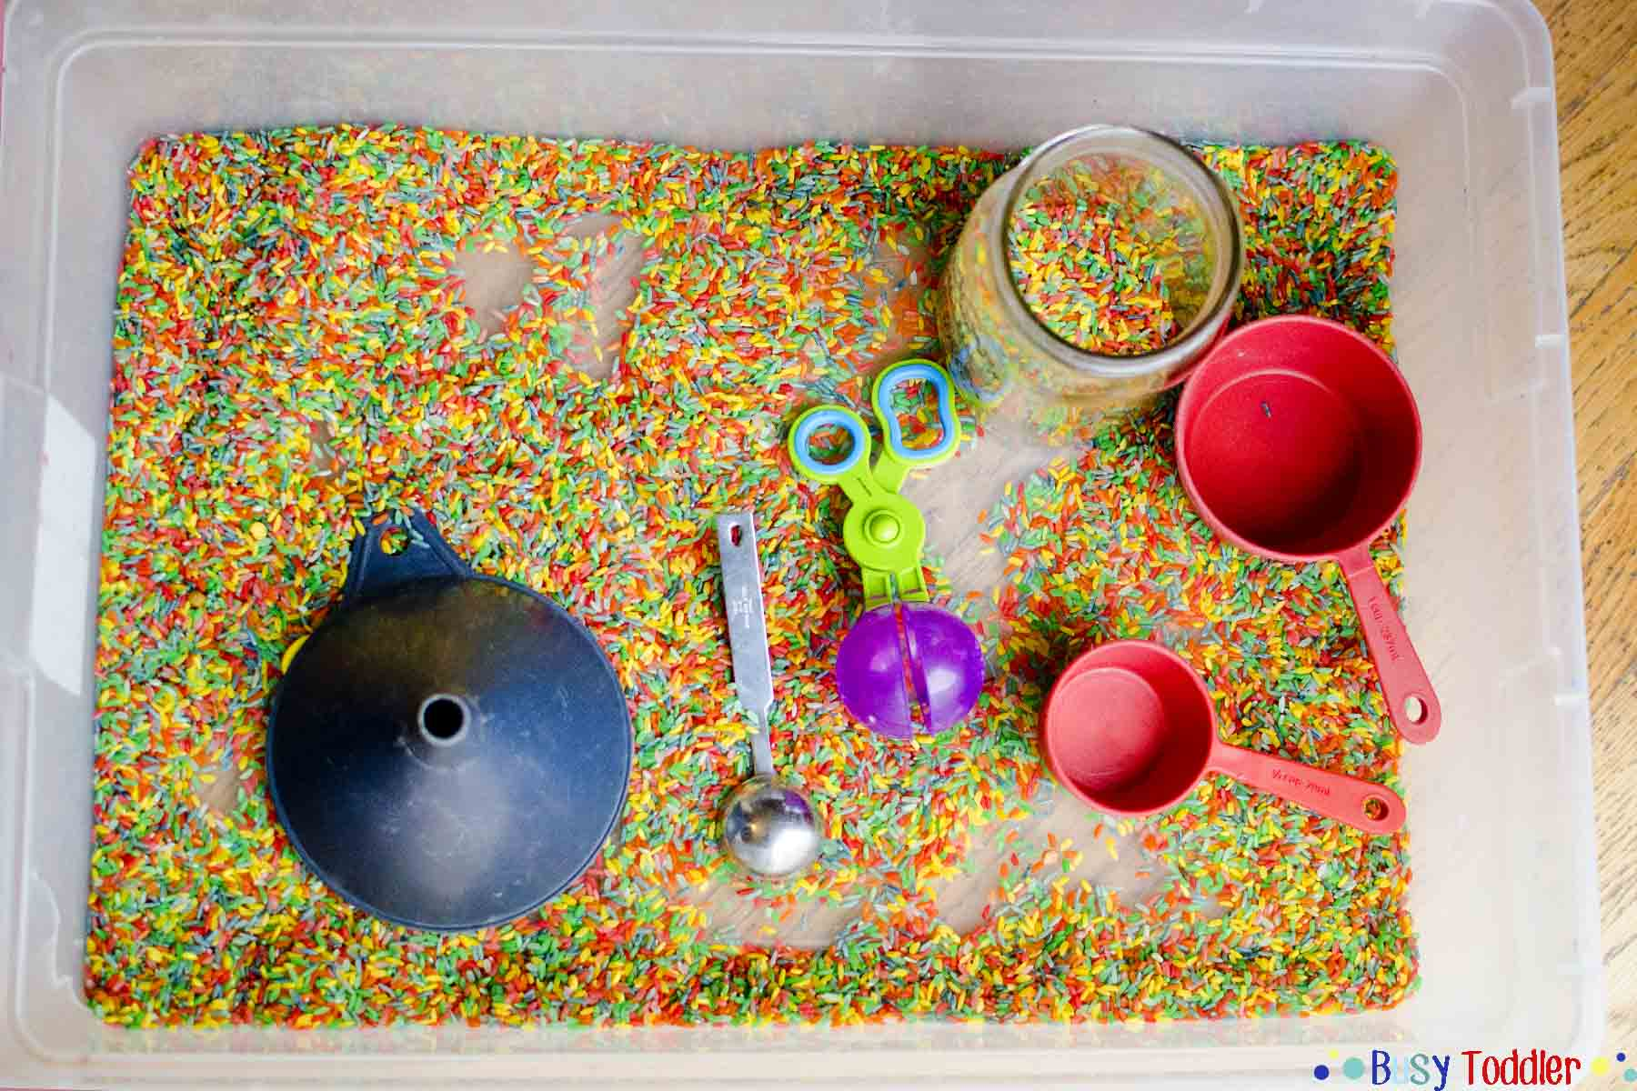
Rice, pasta, dry cereal etc:
Pour the rice or pasta into a bowl or tray. Give your child cups, spoons, scoops, sieves etc to use with the messy play. Look around the kitchen for items that will be fun to use.
Let the child explore the messy play tray by touching, scooping, filling containers and pouring back out again. This will help them to develop their fine-motor skills and will teach them to use different tools for a purpose.
Your role is to play alongside and model new actions and explorations. Your child won’t necessarily copy you straight away, but by showing them different ideas of things they could do, they will gradually experiment more.
You can also introduce key words to comment on what you or they are doing. For example, counting as you drop pieces of pasta into a bowl or saying ‘full’, ‘empty’, ‘in’, ‘scoop’ etc as they fill and pour with containers. This will teach them key language and what it means in a practical way. We have included a chat board with key words and symbols to support their play, but use the words that are most relevant to the actions they choose to carry out.

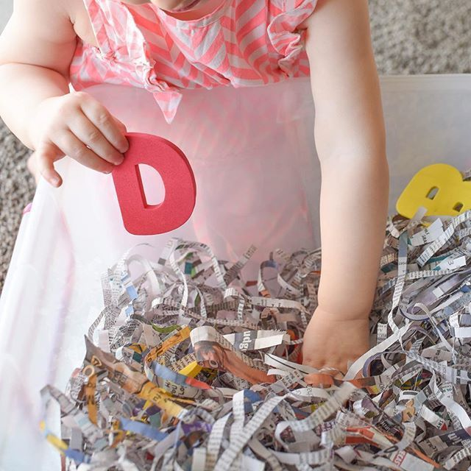
Shredded paper:
Shredded paper is a nice sensory tactile experience. You could hide some of their favourite toys inside the paper for them to look for and find or add shapes, numbers or toy animals. When they find an item, you can name it for them. If they are able to match items, you could have pairs of items hidden for them to find and match.

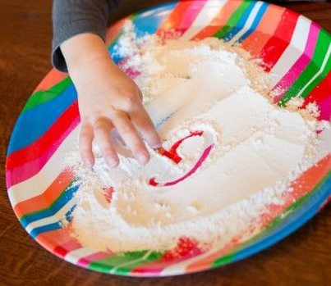
Cornflour:
Cornflour can be used for lots of different messy play activities. If you have a wide, shallow tray or a large plate, you can sprinkle the dry cornflour and use a paintbrush or fingers to do mark-making activities. Model making different marks in the powder, moving up and down or making circles. Some children might be able to copy letter shapes.
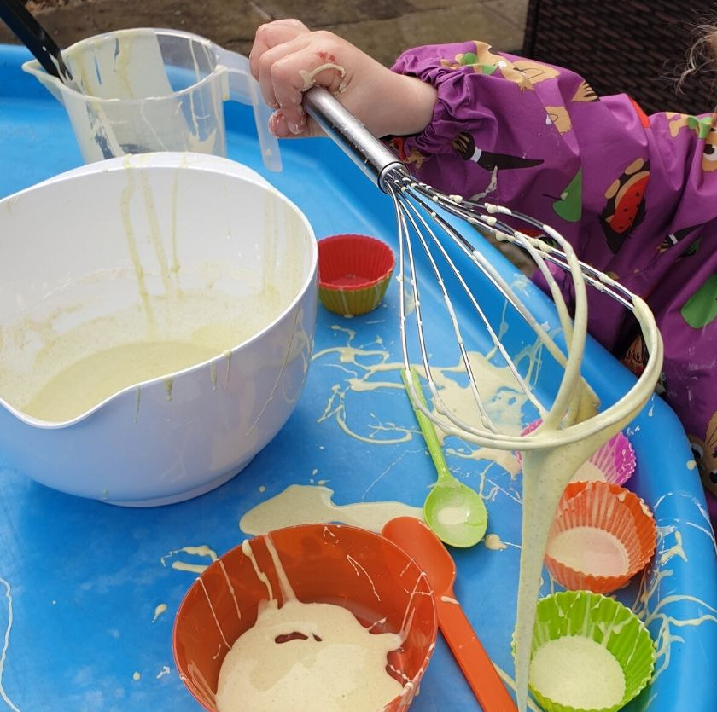
If you’re happy for a little more mess, add some water to the cornflour, about half as much water as flour. When you grab or squeeze the wet cornflour, it will become solid, and when you let go it will drip and flow. This is great fun to use with whisks, colanders and spoons.

We have made a video showing how to make lots of different messy play with cornflour, including frozen chalk and moon sand.
The video can be found here: https://vimeo.com/415922429

